What is java?

Java is object oriented programming language which is developed by sun microsystem in 1995.

It was invented by James gosling that is known as “Father of Java technology.”

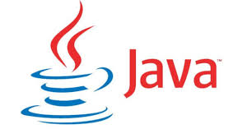

History of Java

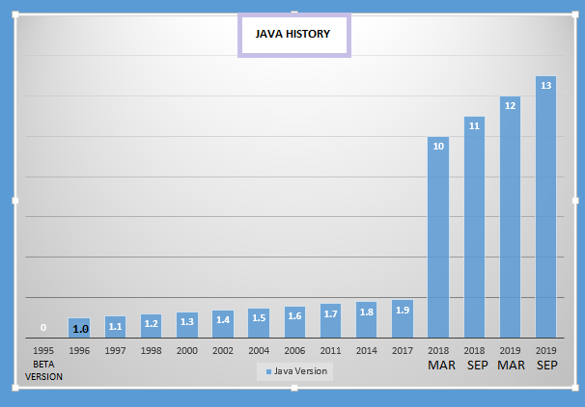

Features of Java

There is some list of features of this language as below.

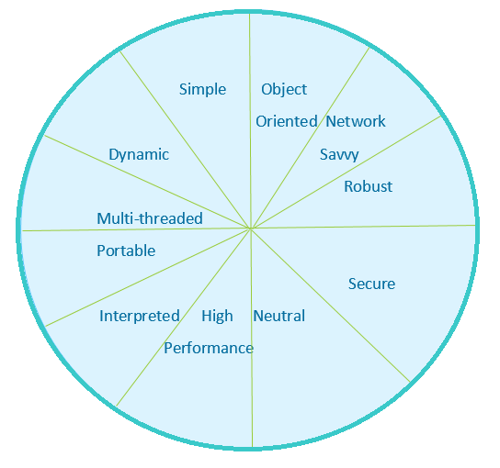

* Simple
* Platform independent
* Neutral
* Portable
* Secure
* Object-Oriented
* Multithreaded
* Robust
* Interpreted
* High Performance
* Distributed
* Dynamic
* Network savvy

1. Simple

It is simple because it is easy to learn, no need to write any header files like C or C++, no concepts of pointers, easy to understand the syntax. There are no any perquisites to learn java.

1. Platform independent-

It follows WORA principle, write once run anywhere. We can run same java program on windows, Linux and mac also.

1. Architecture-Neutral

Suppose I have one java program which is already running on machine that uses window operating system then I upgrade it then to windows 10, RAM size 2 GB to 4 GB. Same java program can be running so need of any changes into it.

1. Portable

It is portable because converting source code into byte code that byte code can run on any platform that’s why it is portable.

1. Secure

With the help of Java we can develop virus free system. It is very secure programming language which is mostly used in banking industry. Some list of security features is encryption, decryption, cryptography, SSL, etc. it has facility to read or write files without permission.

1. Object-Oriented

Everything in java is object, without objects we can’t do anything in java. It has best mechanism oops concepts which includes concept like inheritance, encapsulation, polymorphism, abstraction, class and objects.

1. Multithreaded

It is the best features in java programming languages.

Because it has performs the multiple tasks simultaneously. It shares the common memory area. For example typing the some code into notepad and listing the music so these are two tasks perform the simultaneously.

1. Robust

There is no need of pointer concept to access string, array, file, etc. Garbage collection is done automatically so no need to do it manually like other programming languages. It avoids the memory leakage problems.

1. Interpreted

Java interpreter can execute java byte code directly on any machine to which interpreter has been ported. The byte code is translated into machine code by Just-in-time compiler called as interpreter.

1. High Performance

It provides high performance due to Just-in-time compiler because it has more information available i.e. which code is executed frequently, which classes has been loaded, optimize the code for better speed.

1. Distributed

Java also supports the RMI (Remote Method Innovation). This feature enables program to invoke the method across the network.

1. Network Savvy

It provides facility to access the java application from across the internet via URL’s. It also supports the socket programming for sending the message from client to server.

1. Dynamic

It is considered as dynamic because of byte code. The source code which is written in one platform that code can be executed in any platform. It loads the class file during the runtime only. Hence anything that happens in runtime is dynamic.